2025

Atlantic University Rowing Championships

Lake Banook
Dartmouth, NS

October 25th, 2025

Hosted by


Row Nova Scotia welcomes:

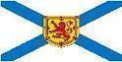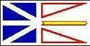

TABLE OF CONTENTS
2025 Atlantic University Rowing Championships 1
TABLE OF CONTENTS 2
WELCOME FROM THE CHAIR 3
ORDER OF EVENTS 4
RULES AND REGULATIONS 5
APPLICABILITY OF RULES 5
REGISTRATION 5
CLUB ELIGIBILITY 6
COMPETITOR ELIGIBILITY 7
ATLANTIC UNIVERSITY ROWING CHAMPIONSHIPS 7
EVENTS 7
LOCHABER CUP 7
MISCELLANEOUS 8
COURSE MAPS 9
Race Course Map 10
Finish Area Map 11
DIRECTIONS 12

2025 Atlantic University Rowing Championships

The 2025 Atlantic University Rowing Championships (ARCs) are being hosted by Row Nova Scotia on Saturday, October 25th. The Atlantic University Rowing Championships brings together university crews from across Atlantic Canada to compete on the beautiful, world-class 1000m racecourse on Lake Banook in Dartmouth, NS, and to award the Lochaber Cup to the top overall university team.

All races will be 1000m and for events with a large number of entries, time trials will be used to determine seeding for finals.

We encourage family, friends, former rowers and those who have never seen rowing to come out and watch the event. Row Nova Scotia is always looking for new volunteers to help out with timing and on the safety boats. No experience is needed. It is the best seat on the lake and a great way to give back to rowing. If you are interested in helping out in some capacity at the regatta please sign up using the following link or email rowing@rowns.ca.
https://www.signupgenius.com/go/5080F45A9A82CA6FB6-59348023-2025

Regatta Chair

2025 Atlantic University Rowing Championship

Proposed order of events. Subject to change based on entries.

Event # | Saturday, October 25, 2025
1 | Women’s 1x
2 | Women’s Novice 4+
3 | Men’s Novice 2x
4 | Women’s lwt 1x
5 | Men’s 8+
6 | Women’s Novice 2x
7 | Men’s lwt 1x
8 | Women’s Novice 8+
9 | Men’s 2x
10 | Women’s lwt 4+
11 | Men’s lwt 2x
12 | Men’s Novice 8+
13 | Women’s 2x
14 | Men’s 1x
15 | Men’s Novice 4+
16 | Women’s lwt 2x
17 | Men’s lwt 4+
18 | Women’s 2-
19 | Men’s Novice 4x
20 | Men’s 2-
21 | Women’s Novice 4x
22 | Women’s 8+

RULES AND REGULATIONS
APPLICABILITY OF RULES
- Unless otherwise noted in the package, the RCA Rules of Racing will be followed.
REGISTRATION

- Registration will be completed online using Regatta Central at the following link:
  - If you are new to Regatta Central you will need to create an account on Regatta Central (https://www.regattacentral.com/signup)
  - Add your Club Affiliation and then contact support and ask to be an administrator for the club (support@regattacentral.com)
  - Add athletes to your club (names, RCA #'s, birthdays).
  - Search for the Regatta you wish to enter and add your boats to the races.
  - Add your crew lineups to the boats.

- There is a regatta registration fee for each crew entry in each event at the regatta:
Single (1x) | $25.00 + seat fees
Double/Pair (2x/2-) | $35.00 + seat fees
Quad/Four/Coxed  Four (4x/4-/4+) | $45.00 + seat fees
Eight (8+) | $55.00 + seat fees
The 2025 fee structure is $4.30 RCA seat fee and $1.25 Row NS seat fee per race event. This is being charged in addition to paying the regatta registration.
- RCA membership numbers of all participants are required. Registration will be verified through RCA and participants who are not registered with RCA will not be allowed to participate. US Rowing participants must include their registration number on the entry form as well.
- We ask that clubs please follow the payment procedures outlined below:
- All regatta entry fees can be paid on Regatta Central or by cash, cheque (made payable to Row Nova Scotia), or e-transfer (rowing@rowns.ca) the weekend of the regatta.
- All seat fees should be paid online through Regatta Central following the regatta. Please choose the option to defer payment when completing your entries. The deadline to pay these fees online will be one week following the regatta at midnight, so race entries will be updated in Regatta Central.
- Entries can be made using Regatta Central. Entries will open October 10, 2025 and close October 17, 2025 at midnight.
- Scratches received after Tuesday, October 21, 2025 at midnight will forfeit entry fees unless there is a suitable medical excuse.
- Late entries may be accepted after the registration deadline of October 17, 2025 at midnight. Acceptance of late entries will be at the discretion of the Regatta Organizing Committee. There will be a late entry fee of the lesser of $15.00 per individual entry or $125.00 per club entry.
- The number of individual club entries in each event may be restricted to a maximum of three (3). Additional entries may be allowed if space permits. Each competitor may be restricted to a maximum of four (4) events.
- Event entries must be made to ensure to eliminate the possibility of participants being in back-to-back races and “hot seating”.
- A preliminary regatta draw will be released on October 22, 2025. Clubs that need to make changes to their entries based on the preliminary draw should email the changes to Row Nova Scotia (rowing@rowns.ca) by the end of the day on October 23, 2025. The final regatta draw will be released after the coaches meeting on October 24th, and at this point we will not be accepting changes to the regatta draw.
Please be advised that the race schedule is subject to change depending on the number of the entries per event. Some events may be canceled or combined.
- The week before the regatta a Safety and Course Document will be sent to all clubs registered. The information in this document will be covered and reviewed at the coaches and officials meeting on Friday night before the regatta, Friday October 24, 2025, at 6:30pm at Oakwood House. It is mandatory for a representative from each club to attend. It is highly recommended that coxes and bow seat competitors attend this meeting.
- Weigh-ins will take place for lightweight rowers at Oakwood House between 6:15 am and 7:00 am on the morning of their event. Athletes must weigh while wearing their racing uniforms. Crews must weigh-in together and athletes must have identification upon request. Multiple weigh-ins will be allowed during the weigh-in window. There will be no test scale for practice weigh-ins. There will be weigh-ins for coxswains.
a. Maximum weight for Lightweight men is 72.5kg.
b. Maximum weight for Lightweight women is 59.0kg.
c. Minimum weight for a coxswain is 55 kg.
If under the minimum weight, a coxswain shall carry deadweight to make up the difference between the weight of the coxswain and the minimum required weight up to a max of 15kg.

Club Eligibility
- Clubs must be in good standing with RCA or their respective member federation to be qualified to participate at the regatta.
- All athletes at the regatta must be represented in consistent club colors. Although it is understood that a variety of rowing uniforms are available such as singlets, unisuits etc., officials of the regatta must see a clear consistency in the color and pattern worn by all members representing one club.

Competitor Eligibility
- Competitors must be students, registered full-time (minimum course load of 3 courses per term) at the University or College they are racing for (in an undergraduate, graduate, or professional program).
- All university / college rowers must be registered with a Rowing Canada Aviron member club. The RCA member club name must be listed on the entry form in conjunction with their university team name if that name is different from their RCA member club name.
- Any member of a National Team (Sr. A, Sr. B, Junior, and Para) is permitted to participate in any event provided they represent their university / college and not a National Team Training Centre, Rowing Canada Aviron or US Rowing.
- Competitors may participate as a member of a composite crew (two or more universities / colleges) but that crew is not eligible for club points.
- Row Nova Scotia recognizes the following classifications at the AURC Regatta:
University | University Men/Women | A rower who is a student registered full-time (minimum course load of 3 courses per term) at the University or College they are racing for (in an undergraduate, graduate, or professional program).
Lwt M/W | Lightweight Men/Women | Men - 72.5 kg maximum;  Women - 59.0 kg maximum.  No average for lightweight events
N M/W | Novice Men/Women | A rower who has not competed in a sanctioned on-water regatta prior to April 1 of the current year.

ATLANTIC UNIVERSITY ROWING CHAMPIONSHIPS
Events
- The Atlantic University Rowing Championships will have the following event classifications:
Classification | Gender | 1X | 2X | 2- | 4X | 4+ | 8+
Novice | Men |  | X |  | X | X | X
Novice | Women |  | X |  | X | X | X
University | Men | X | X | X |  |  | X
University | Lwt Men | X | X |  |  | X
University | Women | X | X | X |  |  | X
University | Lwt Women | X | X |  |  | X

THE LOCHABER CUP
- The Lochaber Cup was donated by the Brothers family of Lochaber, in recognition of the overall points winner of the Atlantic University Rowing Championships combined between the varsity men’s and women’s programs.
- Championship banners will be awarded to the winner of the varsity men’s and varsity women’s events respectively – Novice crews will not score points towards the varsity championships.
- Points will be awarded as per the point schedule listed below. For each event, only the top place crew/sculler from each school will be awarded points; subsequent finishers will not score points, and the point value for their placing will not be awarded.
Placing/ Boat | 1 | 2 | 3 | 4 | 5 | 6 | 7 | 8 | 9 | 10 | 11 | 12
1x | 15 | 12 | 10 | 9 | 8 | 7 | 6 | 5 | 4 | 3 | 2 | 1
2x/- | 20 | 16 | 12 | 10 | 9 | 8 | 7 | 6 | 5 | 4 | 3 | 2
4x/+ | 25 | 20 | 15 | 12 | 10 | 9 | 8 | 7 | 6 | 5 | 4 | 3
8+ | 40 | 35 | 30 | 25 | 22 | 20 | 19 | 18 | 17 | 16 | 15 | 14
- Medals are awarded to first place crews in each event final.

MISCELLANEOUS

- Row Nova Scotia is in search of the volunteers to help out in various positions: safety boat drivers, safety boat assistants and timers. If you have any questions regarding volunteering please contact rowing@rowns.ca, or visit

https://www.signupgenius.com/go/5080F45A9A82CA6FB6-59348023-2025

- Boats and Trailers can be parked in the parking lot at North Star Rowing Club and on site security for the boats will be provided from 7pm Friday to 6 am Saturday* at North Star Rowing Club.
* - Security will be present from 7pm Saturday to 6am Sunday for clubs participating in the Really Chili Regatta on October 26, 2025.

- There will be no designated practice time on the course on Friday or pre-row before the regatta. Any club or rower who would like to use the lake outside of regatta times must do so at their own risk, and using their own safety boats (or rented from clubs). The course must be cleared of pre-row by 7:00am to begin the regatta.

- Food options will not be available on-site during the regatta to purchase. Food will be prepared for the volunteers and umpires only. Coaches and rowers should come prepared with other nutrition options.

COURSE MAPS

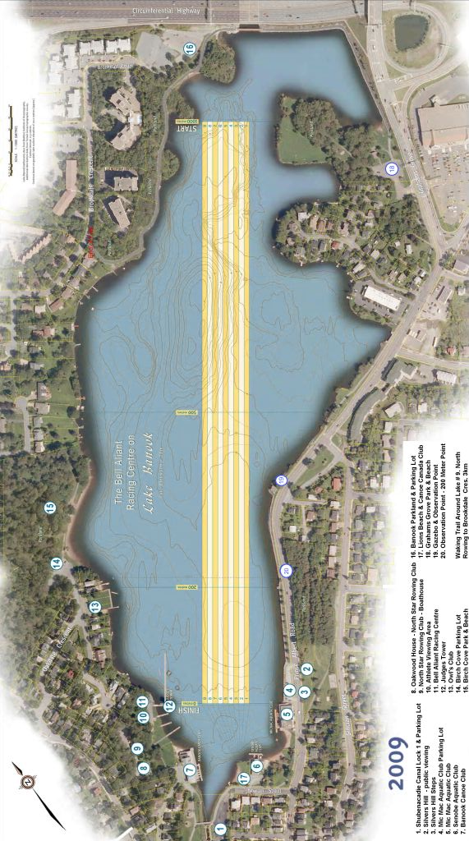

Race Course Map
- North Star Rowing & Judges Tower (See Finish Area Map)  - MicMac AAC  - Gazebo (Spectator Observation & Boardwalk)  - Graham’s Grove Park (Start-line Observation)  - Conrad Footbridge  - MicMac Mall |  | From Trans Canada  Walking Trail  Warm-up/Cool-down Flow Race Course Flow

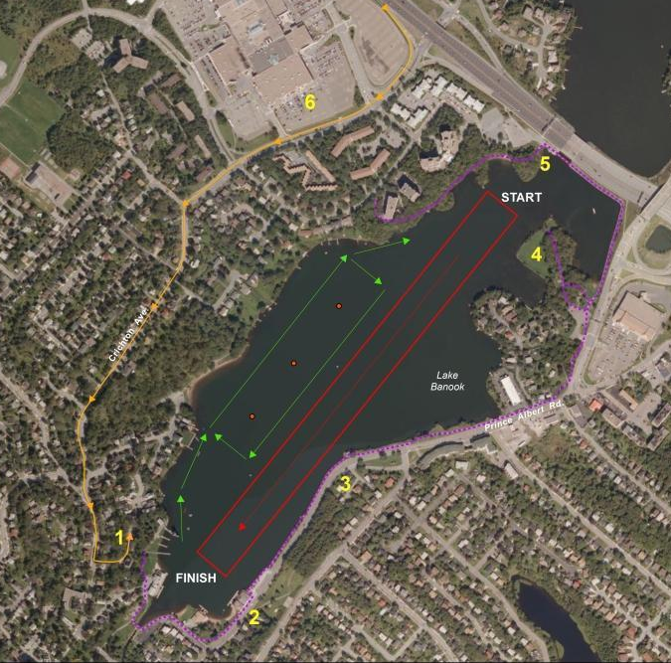

Note:If Clubs informally practice on Friday PM, the Practice Flow Pattern is:
Up Mic Mac side of the course and down the lanes

Finish Area Map
1. Judges Tower  - Medical  - Control  - Results  - Official Launch  2. Launch Area  - Dock Marshall  - General Information  - Vendors  3. Trailer Parking  4. North Star Rowing  5. Oakwood House  - Safety Meeting  - Medal Ceremony  6. General Parking  7. MicMac AAC |  | Trailer Parking From Trans Canada  Walking Trail  Outflow  Inflow
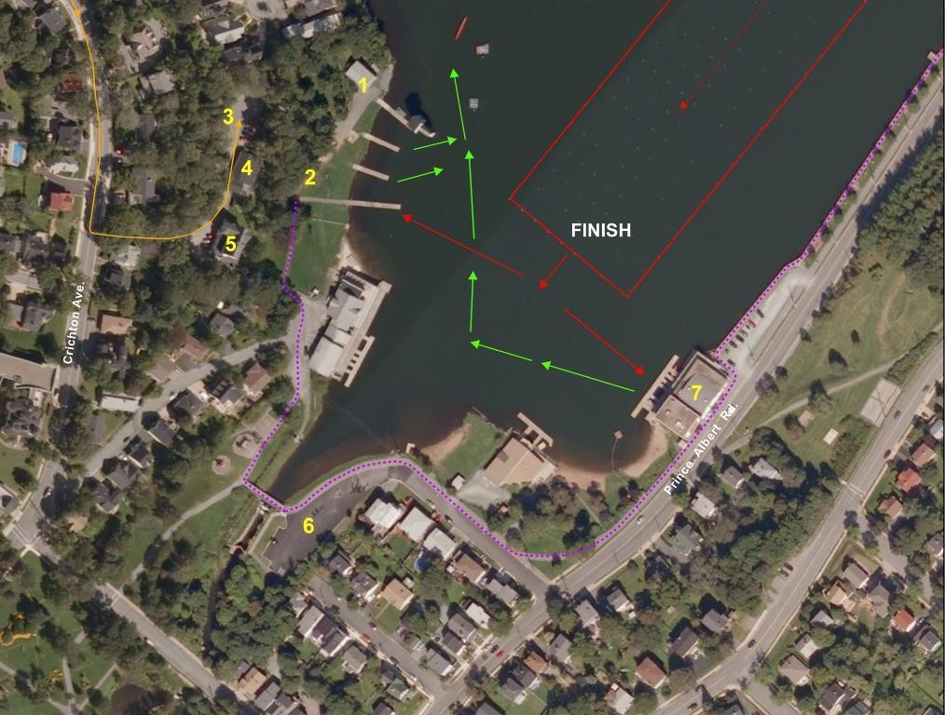

DIRECTIONS
From Trans Canada Highway, Provincial Route 118
• Take Right Exit to Eastern Shore/Eastern Passage onto Highway 111
• Drive 0.5km and Exit 5 to MicMac Boulevard
• Follow MicMac Blvd changing to Glen Manor Dr. to stop sign at top of hill.
• Turn left onto Crichton Ave.
• Follow Crichton Ave approx. 850m to sign for Oakwood House and Banook Canoe Club;. Turn Left onto this steep descent into the Trailer Parking Area.

IF YOU GET LOST IN THE HALIFAX/DARTMOUTH AREA:
Ask for directions to Banook Canoe Club. Banook Canoe Club is adjacent to the North Star Rowing Club and Oakwood House.

