# **2025**

# **Atlantic Rowing Championships**

Lake Banook

Dartmouth, NS

October 4th, 2025

Hosted by

****

Row Nova Scotia welcomes:

NovaScotia New_Brunswick Newfoundland

### TABLE OF CONTENTS

[**2025 Atlantic Rowing Championships 1**](#_j0v7yajohmlf)

[TABLE OF CONTENTS 2](#_1sbffd0hy7m)

[WELCOME FROM THE CHAIR 3](#_tcnql1xb2jvy)

[EVENT INFORMATION 4](#_11x43ad37xq4)

[RULES AND REGULATIONS](#_w3s7iknyp8sf) 5

[APPLICABILITY OF RULES](#_u22o3iiek9ep) 5

[REGISTRATION](#_6j3r70a79yjm) 5

[CLUB ELIGIBILITY 6](#_yg2cmpmr0554)

[COMPETITOR ELIGIBILITY 6](#_ic0mljd544d)

[EVENTS](#_topl4xbky3fp) 8

[REGATTA CHAMPIONSHIP 8](#_9uzvpz6q1qv)

Presidents Cup [8](#_rws7w7thpwum)

[EFFICIENCY – NOVA SCOTIA EFFICIENCY AWARD](#_raiq8ng5o6c9) 9

[MISCELLANEOUS](#_3llr3sbw8as7) 9

[COURSE MAPS 10](#_32in73lglkvo)

[Race Course Map 11](#_puomb74f1dvt)

[Finish Area Map 1](#_pdxbyu1kba50)2

[DIRECTIONS 13](#_kfq68v57ctdc)

# **2025 Atlantic Rowing Championships**

The 2025 Atlantic Rowing Championships (ARCs) are being hosted by Row Nova Scotia on Saturday, October 4th. The Atlantic Rowing Championships brings together clubs from across Atlantic Canada to compete on the beautiful, world-class 1000m racecourse on Lake Banook in Dartmouth, NS, and to crown the overall club champion.

All races will be 1000m and for events with a large number of entries, time trials will be used to determine seeding for finals. The ARC regatta will be running championship events at this year’s regatta to increase the competition and quality of racing for all participants.

We encourage family, friends, former rowers and those who have never seen rowing to come out and watch the event. Row Nova Scotia is always looking for new volunteers to help out with timing and on the safety boats. No experience is needed. It is the best seat on the lake and a great way to give back to rowing. If you are interested in helping out in some capacity at the regatta please sign up using the following link or email [rowing@rowns.ca](mailto:rowing@rowns.ca).

<https://www.signupgenius.com/go/5080F45A9A82CA6FB6-58781286-2025>

Regatta Chair

**2025 Atlantic Rowing Championship**

**Proposed order of events. Subject to change based on entries.**

| **Event #** | **Saturday, October 4, 2025** |
| --- | --- |
| **1** | Mixed Masters 4x |
| **2** | Men’s Champ 1x |
| **3** | Women’s Champ 2x |
| **4** | Men’s Masters 4x |
| **5** | Women’s Masters 8+ |
| **6** | Men’s Champ 2- |
| **7** | Women’s Champ 1x |
| **8** | Women’s Novice 4x |
| **9** | Men’s Novice 2x |
| **10** | Men’s Champ 8+ |
| **11** | Women’s Champ 4- |
| **12** | Men’s Masters 1x |
| **13** | Women’s Masters 2x |
| **14** | Men’s Novice 4x |
| **15** | Women’s Novice 1x / Para 1x |
| **16** | Women’s Champ 2- |
| **17** | Men’s Champ 4- |
| **18** | Men’s Masters 2x |
| **19** | Men’s Novice 1x |
| **20** | Women’s Masters 4x |
| **21** | Women’s Champ 8+ |
| **22** | Men’s Champ 4x |
| **23** | Women’s Novice 2x / Para 2x |
| **24** | Men’s Masters 8+ |
| **25** | Women’s Masters 1x |
| **26** | Men’s Champ 2x |
| **27** | Women’s Champ 4x |
| **28** | Mixed Masters 2x |

## 

## **RULES AND REGULATIONS**

**APPLICABILITY OF RULES**

1. Unless otherwise noted in the package, the RCA Rules of Racing will be followed.

**REGISTRATION**

1. Registration will be completed online using Regatta Central at the following link:
   1. If you are new to Regatta Central you will need to create an account on Regatta Central (<https://www.regattacentral.com/signup>)
   2. Add your Club Affiliation and then contact support and ask to be an administrator for the club ([support@regattacentral.com](mailto:support@regattacentral.com))
   3. Add athletes to your club (names, RCA #'s, birthdays).
   4. Search for the Regatta you wish to enter and add your boats to the races.
   5. Add your crew lineups to the boats.
2. There is a regatta registration fee for each crew entry in each event at the regatta:

| Single (1x) | $25.00 + seat fees |
| --- | --- |
| Double/Pair (2x/2-) | $35.00 + seat fees |
| Quad/Four/Coxed  Four (4x/4-/4+) | $45.00 + seat fees |
| Eight (8+) | $55.00 + seat fees |

The 2025 fee structure is $4.30 RCA seat fee and $1.25 Row NS seat fee per race event. This is being charged in addition to paying the regatta registration.

1. RCA membership numbers of all participants are required. Registration will be verified through RCA and participants who are not registered with RCA will not be allowed to participate. US Rowing participants must include their registration number on the entry form as well.
2. We ask that clubs please follow the payment procedures outlined below:

* All regatta entry fees can be paid on Regatta Central or by cash, cheque (made payable to Row Nova Scotia), or e-transfer (rowing@rowns.ca) the weekend of the regatta.
* All seat fees should be paid online through Regatta Central following the regatta. Please choose the option to defer payment when completing your entries. The deadline to pay these fees online will be one week following the regatta at midnight, so race entries will be updated in Regatta Central.

1. Entries can be made using Regatta Central. Entries will open September 19, 2025 and close September 29, 2025 at midnight.
2. Scratches received after the registration deadline on September 29, 2025 at midnight will forfeit entry fees unless there is a suitable medical excuse.
3. Late entries may be accepted after the registration deadline of September 29, 2025 at midnight. Acceptance of late entries will be at the discretion of the Regatta Organizing Committee. There will be a late entry fee of the lesser of $15.00 per individual entry or $125.00 per club entry.
4. The number of individual club entries in each event may be restricted to a maximum of three (3). Additional entries may be allowed if space permits. Each competitor may be restricted to a maximum of four (4) events.
5. Event entries must be made to ensure to eliminate the possibility of participants being in back-to-back races and “hot seating”.
6. A preliminary regatta draw will be released on October 1, 2025. Clubs that need to make changes to their entries based on the preliminary draw should email the changes to the regatta statistician by the end of the day on October 2, 2025. On October 3, 2025 the final regatta draw will be released and at this point we will not be accepting changes to the regatta draw.

Please be advised that the race schedule is subject to change depending on the number of the entries per event. Some events may be canceled or combined.

1. The week before the regatta a Safety and Course Document will be sent to all clubs registered. The information in this document will be covered and reviewed at the coaches and officials meeting on Friday night before the regatta, Friday October 3, 2025, at 6:30pm at Oakwood House. It is **mandatory** for a representative from each club to attend. It is highly recommended that coxes and bow seat competitors attend this meeting.
2. Weigh-ins will take place for lightweight rowers at Oakwood House between 6:15 am and 7:00 am on the morning of their event. Athletes must weigh while wearing their racing uniforms. Crews must weigh-in together and athletes must have identification upon request. Multiple weigh-ins will be allowed during the weigh-in window. There will be no test scale for practice weigh-ins. There will be weigh-ins for coxswains.

a. Maximum weight for Lightweight men is 72.5kg.

b. Maximum weight for Lightweight women is 59.0kg.

**Club Eligibility**

1. Clubs must be in good standing with RCA or their respective member federation to be qualified to participate at the regatta.
2. All athletes at the regatta must be represented in consistent club colors. Although it is understood that a variety of rowing uniforms are available such as singlets, unisuits etc., officials of the regatta must see a clear consistency in the color and pattern worn by all members representing one club.

**Competitor Eligibility**

1. All competitors, including coxswains, may participate in multiple events. Each competitor may be restricted to a maximum of four (4) events. Competitors and clubs are responsible for allowing sufficient time to race in one event, dock, re-queue, and launch in time for an additional event. The regatta and umpires will not wait for late arriving crews.
2. Any member of a National Team (Sr. A, Sr. B, Junior, and Para) is permitted to participate in any event provided they represent their home club and not a National Team Training Centre, Rowing Canada Aviron or US Rowing.
3. A competitor who is a member of more than one (1) club must select which club they will represent.
4. Competitors may participate as a member of a composite crew (two or more clubs) but that crew is not eligible for club points.
5. Row Nova Scotia recognizes the following classifications at the ARC Regatta:

| **U19 M/W** | **Under 19 Men/Women** | A rower or coxswain who shall be classified as an Under 19 competitor until the 31st of December of the year in which they reach the age of 18. |
| --- | --- | --- |
| **U23** | **Under 23 Men/Women** | A rower or coxswain may compete as an Under 23 competitor until the 31st of December of the year in which they reach the age of 22 |
| **SR M/W** | **Senior Men/Women** | A rower or coxswain who is no longer eligible as an Under 23 rower. |
| **M M/W** | **Masters Men/Women** | A rower may compete as a Masterfrom the beginning of the year during which they attain the age of 21. |
| **Lwt M/W** | **Lightweight Men/Women** | Men - 72.5 kg maximum;  Women - 59.0 kg maximum.  No average for lightweight events Any athlete competing as a lightweight must be 19 years of age or older |
| **Para M/W** | **Para Men/Women** | A rower with a disability who meets the criteria set out in the Para Rowing classification rules.  There are three PARA categories:  1. PR1 (Arms and shoulders)  2. PR 2 (trunk and arms)  3. PR 3 (leg, trunk and arms)  Para athletes are eligible to row in para and non-para events in the same regatta. |
| **N M/W** | **Novice Men/Women** | A rower who has not competed in a sanctioned on-water regatta prior to April 1 of the current year. |
| **Mix** | **Mixed Men / Women** | A crew in which no more than half of the rowers in each crew shall identify as male, excluding the coxswain. |

**ATLANTIC ROWING CHAMPIONSHIPS**

**Events**

1. The Atlantic Rowing Championships will have the following event classifications:

| **Classification** | **Gender** | **1X** | **2X** | **2-** | **4X** | **4-** | **8+** |
| --- | --- | --- | --- | --- | --- | --- | --- |
| **Novice** | Men | X | X |  | X |  |  |
| Women | X | X |  | X |  |  |
| **Championship Events (U19, U23, U23 LW, Senior, Senior LW)** | Men | X | X | X | X | X | X |
| Women | X | X | X | X | X | X |
| **Master** | Men | X | X |  | X |  | X |
| Women | X | X |  | X |  | X |
| Mixed |  | X |  | X |  |  |
| **Para** | Mix | X | X |  |  |  |  |
| Men | X | X |  |  |  |  |
| Women | X | X |  |  |  |  |

1. Championship races will include Under 19, Under 23, Senior and associated lightweight category competitors. All athletes will race together, regardless of classification. For each championship event, the following winners will be awarded:
2. The top finisher in the A final.
3. The top U19, Under 23, Senior and associated lightweight boats.
4. For Master events the Garrett Masters Age Adjusted Time System will be applied with the exception of Masters competitors in the AA category (ages 21-26) who will race using their unadjusted time. The adjustment will be applied to a single sculler or, in the case of a crew boat, the average age of the crew excluding the coxswain.
5. All events with five or less entries will be run as straight finals and race assignments will be determined randomly. In events with more than five boats, time trials will be used to determine seeding for finals with the exception of Masters events which will not run time trials.
   1. Where Masters age categories are not applicable due to the number of entries in categories, the average age of boats will be used to create finals of similarly aged boats and the winner of each final will be awarded based on Masters age adjusted times.

**The President’s Cup**

1. The President’s Cup was donated by Row NS, in recognition of the overall points winner of the Atlantic Rowing Championships. Following the awards, presentation of the cup will remain with Row NS, and the winning team will receive a banner to hang in their clubhouse.
2. Points will be awarded as per the point schedule listed below. Only the top three placing crews from each club will be awarded points; subsequent finishers will not score points, and the point value for their placing will not be awarded.

| **Placing/ Boat** |  | **1** | **2** | **3** | **4** | **5** | **6** | **7** | **8** | **9** | **10** | **11** | **12** |
| --- | --- | --- | --- | --- | --- | --- | --- | --- | --- | --- | --- | --- | --- |
| **1x** |  | 15 | 12 | 10 | 9 | 8 | 7 | 6 | 5 | 4 | 3 | 2 | 1 |
| **2x/-** |  | 20 | 16 | 12 | 10 | 9 | 8 | 7 | 6 | 5 | 4 | 3 | 2 |
| **4x/+/-** |  | 25 | 20 | 15 | 12 | 10 | 9 | 8 | 7 | 6 | 5 | 4 | 3 |
| **8+** |  | 40 | 35 | 30 | 25 | 22 | 20 | 19 | 18 | 17 | 16 | 15 | 14 |

1. There will be no points awarded for composite crews, exhibition crews or races that do not have a minimum of two entries from different clubs.

**Efficiency – Atlantics Efficiency Award**

1. "Actual Points" are the cumulative points earned by each club. "Possible Points" are calculated as if each crew entered by a club placed first in their respective event. If a club has more than one boat in an event, the "possible points" are calculated as 1st, 2nd, 3rd position scores, since only one of the boats can place first.
2. The "Efficiency" is the percentage of Total Actual Points divided by Total Possible Points. The club that qualifies, and is the most efficient in its overall entries throughout the regatta, is the winner.
3. To be eligible for the club efficiency award a club must:
4. have crews participate in at least four (4) A Finals.
5. enter a minimum of 14 participants in the regatta.

**MISCELLANEOUS**

1. For each event, medals will be awarded to first place winners in A Finals and applicable age group winners. Medals will also be awarded to the winner of each Masters Final.

1. Row Nova Scotia is in search of the volunteers to help out in various positions: safety boat drivers, safety boat assistants and timers. If you have any questions regarding volunteering please contact [rowing@rowns.ca](mailto:rowing@rowns.ca)**,** or visit <https://www.signupgenius.com/go/5080F45A9A82CA6FB6-58781286-2025>
2. Boats and Trailers can be parked in the parking lot at North Star Rowing Club and on site security for the boats will be provided from 7pm Friday to 6 am Saturday at North Star Rowing Club.
3. There will be no designated practice time on the course on Friday or pre-row before the regatta. Any club or rower who would like to use the lake outside of regatta times must do so at their own risk, and using their own safety boats (or rented from clubs). The course must be cleared of pre-row by 7:00am to begin the regatta.
4. Food options will not be available on-site during the regatta to purchase. Food will be prepared for the volunteers and umpires only. Coaches and rowers should come prepared with other nutrition options.

## **COURSE MAPS**

## **Race Course Map**new-site-map-smallROWnovascotia_small_RGB

| 1. North Star Rowing & Judges Tower (See Finish Area Map) 2. MicMac AAC 3. Gazebo (Spectator Observation & Boardwalk) 4. Graham’s Grove Park (Start-line Observation) 5. Conrad Footbridge 6. MicMac Mall |  | From Trans Canada  Walking Trail  Warm-up/Cool-down Flow Race Course Flow |
| --- | --- | --- |

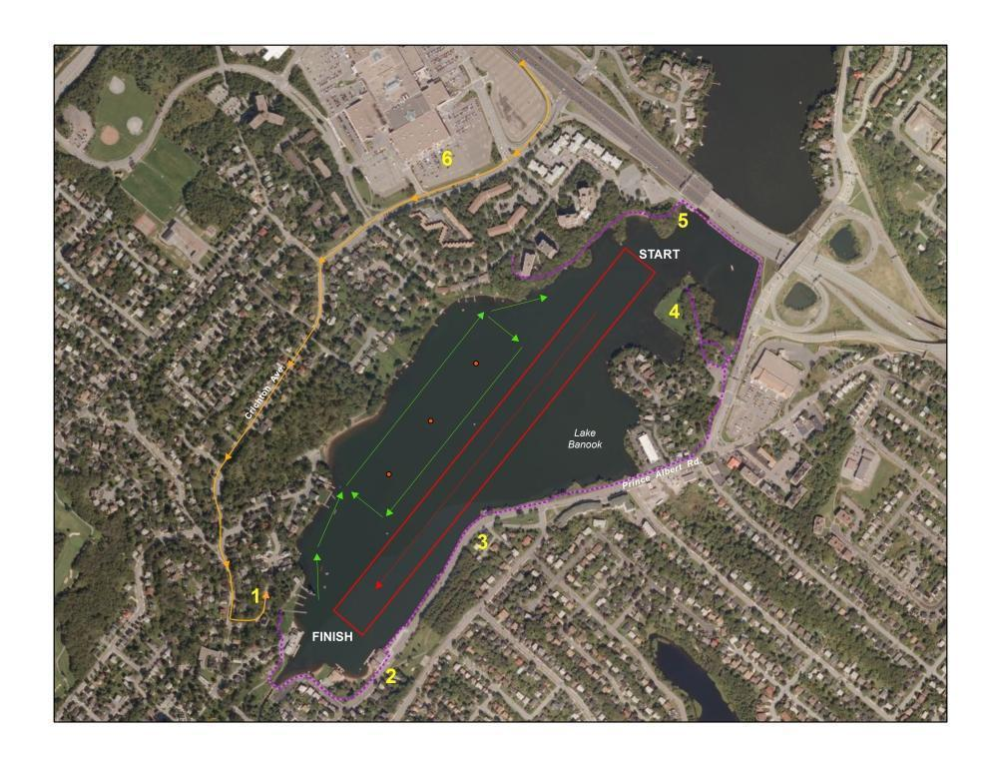

**Note:If Clubs informally practice on Friday PM, the Practice Flow Pattern is:**

**Up Mic Mac side of the course and down the lanes**

## **Finish Area Map**

| 1. Judges Tower   * Medical * Control * Results * Official Launch   2. Launch Area   * Dock Marshall * General Information * Vendors   3. Trailer Parking  4. North Star Rowing  5. Oakwood House   * Safety Meeting * Medal Ceremony   6. General Parking  7. MicMac AAC |  | Trailer Parking From Trans Canada  Walking Trail  Outflow  Inflow |
| --- | --- | --- |

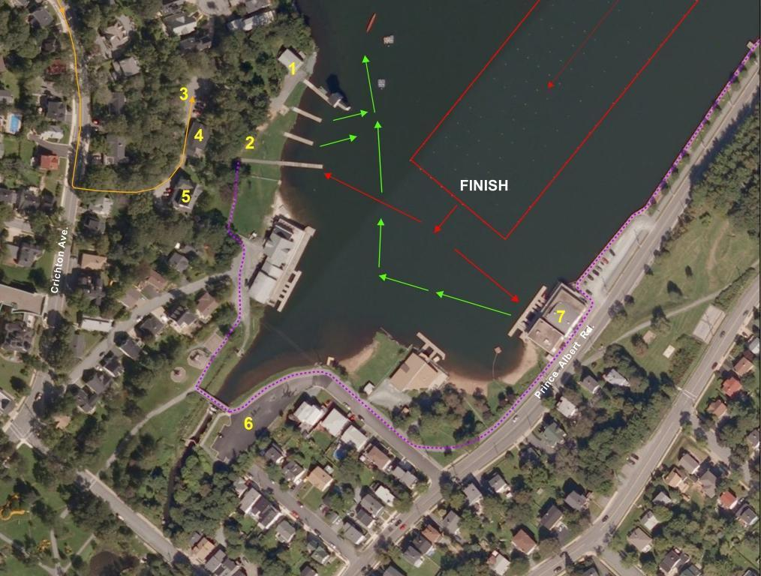

**DIRECTIONS**

From Trans Canada Highway, Provincial Route 118

• Take Right Exit to *Eastern Shore/Eastern Passage* onto Highway 111

• Drive 0.5km and Exit 5 to MicMac Boulevard

• Follow MicMac Blvd changing to Glen Manor Dr. to stop sign at top of hill.

• Turn left onto Crichton Ave.

• Follow Crichton Ave approx. 850m to sign for Oakwood House and Banook Canoe Club;. Turn Left onto this steep descent into the Trailer Parking Area.

IF YOU GET LOST IN THE HALIFAX/DARTMOUTH AREA:

Ask for directions to Banook Canoe Club. Banook Canoe Club is adjacent to the North Star Rowing Club and Oakwood House.

## 