# **2025 NOVA SCOTIA SPRINTS**

## 52nd Annual Bud Myra Memorial Regatta

Lake Banook

Dartmouth, NS

August 30th, 2025

Hosted by



Row Nova Scotia welcomes:

NovaScotia New_Brunswick Newfoundland

Quebec  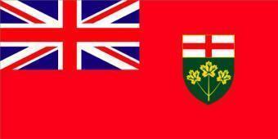

### TABLE OF CONTENTS

[**2025 NOVA SCOTIA SPRINTS 1**](#_heading=h.j0v7yajohmlf)

[52nd Annual Bud Myra Memorial Regatta](#_heading=h.f09q1l95s9p1)

[TABLE OF CONTENTS 2](#_heading=h.1sbffd0hy7m)

[WELCOME FROM THE CHAIR 3](#_heading=h.tcnql1xb2jvy)

[EVENT INFORMATION 4](#_heading=h.11x43ad37xq4)

[RULES AND REGULATIONS 4](#_heading=h.w3s7iknyp8sf)

[APPLICABILITY OF RULES 4](#_heading=h.u22o3iiek9ep)

[REGISTRATION 4](#_heading=h.6j3r70a79yjm)

[CLUB ELIGIBILITY 6](#_heading=h.yg2cmpmr0554)

[COMPETITOR ELIGIBILITY 6](#_heading=h.ic0mljd544d)

[EVENTS 7](#_heading=h.topl4xbky3fp)

[REGATTA CHAMPIONSHIP 8](#_heading=h.9uzvpz6q1qv)

[CUMULATIVE POINTS – OWEN SAWLER MEMORIAL TROPHY 8](#_heading=h.rws7w7thpwum)

[EFFICIENCY – NOVA SCOTIA EFFICIENCY AWARD 8](#_heading=h.raiq8ng5o6c9)

[MISCELLANEOUS 8](#_heading=h.3llr3sbw8as7)

[Robert “Bud” Myra 10](#_heading=h.xotbwcsn8gfa)

[COURSE MAPS 10](#_heading=h.32in73lglkvo)

[Race Course Map 11](#_heading=h.puomb74f1dvt)

[Finish Area Map 13](#_heading=h.pdxbyu1kba50)

[DIRECTIONS](#_heading=h.kfq68v57ctdc) 14

### 

### 

### 

### 

### WELCOME FROM THE CHAIR

Welcome to the 52nd annual Nova Scotia Sprint Regatta that is hosted by Row Nova Scotia (Row NS) and brings together clubs from Eastern Canada to compete on the beautiful world class 1000m racecourse on Lake Banook in Dartmouth, N.S.

Due to unforeseen circumstances, it was necessary to move our flagship regatta to late August and schedule all races to take place on one day. We apologize for any inconvenience this has caused and know that some will be disappointed with these changes. We look forward to getting back to our usual regatta date and format in 2026.

We hope you and your rowers are excited to race and can attend this regatta! All races will be 1000m and for events with a large number of entries, time trials will be used to determine seeding for finals. The Nova Scotia Sprints regatta will be running masters and ‘championship’ events for Under 19, Under 23, and Senior competitors to increase the competition and quality of racing for all participants. Medals will be awarded to first place winners in A Finals and where applicable age group winners.

We encourage family, friends, former rowers and those who have never seen rowing to come out and watch the event, and Row Nova Scotia is always looking for new volunteers to help out with timing and on the safety boats. No experience is needed. It is the best seat on the lake and a great way to give back to rowing. If you are interested in helping out in some capacity at the regatta, please sign up using the following link: <https://www.signupgenius.com/go/5080F45A9A82CA6FB6-57520929-2025>

Sincerely,

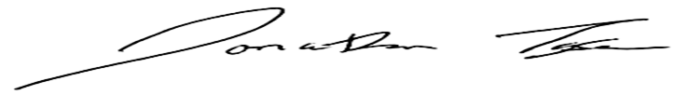

Row Nova Scotia

**2025 Nova Scotia Sprints Events**

**\* Proposed schedule only and may change depending on number of entries.**

|  |  |
| --- | --- |
| **Event #** | **Saturday, August 30, 2025** |
| **1** | Men’s Champ 1x |
| **2** | Women’s Champ 2x |
| **3** | Men’s Masters 4x |
| **4** | Women’s Masters 8+ |
| **5** | Men’s Champ 4+ |
| **6** | Para 1x (PR1 & PR2) |
| **7** | Men’s Novice 2x |
| **8** | Women’s Novice 4x |
| **9** | Men’s Champ 2x |
| **10** | Women’s Champ 1x |
| **11** | Women’s Masters 4x |
| **12** | Men’s Masters 8+ |
| **13** | Men’s Novice 1x |
| **14** | Men’s Champ 4- **(Moe Cody Trophy)** |
| **15** | Women’s Champ 2- |
| **16** | Women’s Masters 1x |
| **17** | Men’s Masters 2x |
| **18** | Para 2x (PR2 & PR3) |
| **19** | Womens Champ 4+ |
| **20** | Women’s Novice 1x |
| **21** | Men’s Champ 4x |
| **22** | Mixed Masters 2x |
| **23** | Women’s Champ 4x |
| **24** | Men’s Novice 4x |
| **25** | Men’s Champ 2- |
| **26** | Men’s Masters 1x |
| **27** | Women’s Masters 2x |
| **28** | Women’s Champ 8+ |
| **29** | Women’s Novice 2x |
| **30** | Men’s Champ 8+ |
| **31** | Mixed Masters 4x |
| **32** | Women’s Champ 4- **(Tom St. Onge Trophy)** |

## 

**\*\*Lightweight rowers will be eligible to compete in the applicable races above**

## RULES AND REGULATIONS

### APPLICABILITY OF RULES

1. Unless otherwise noted in this package, the RCA Rules of Racing will be followed.

### REGISTRATION

1. Registration will be completed online using Regatta Central.
   1. If you are new to Regatta Central you will need to create an account on Regatta Central (<https://www.regattacentral.com/signup>)
   2. Add your Club Affiliation and then contact support and ask to be an administrator for the club ([support@regattacentral.com](mailto:support@regattacentral.com))
   3. Add athletes to your club (names, RCA #'s, birthdays).
   4. Search for the Regatta you wish to enter and add your boats to the races.
   5. Add your crew lineups to the boats.
2. There is a regatta registration fee for each crew entry in each event at the regatta:

|  |  |
| --- | --- |
| Single (1X) | $25.00 + seat fees |
| Double/Pair (2X/2-) | $35.00 + seat fees |
| Quad/Four/Coxed Four (4X/4-/4+) | $45.00 + seat fees |
| Eight (8+) | $55.00 + seat fees |

The 2025 seat fee structure is $4.30 RCA seat fee and $1.25 Row NS seat fee per race event. This is being charged in addition to paying the regatta registration.

1. RCA membership numbers of all participants are required. Registration will be verified through RCA and participants who are not registered with RCA will not be allowed to participate. US Rowing participants must include their registration number on the entry form as well.
2. We ask that clubs please follow the payment procedures outlined below:

* All regatta entry fees can be paid on Regatta Central or by cash, cheque (made payable to Row Nova Scotia), or e-transfer (rowing@rowns.ca) the weekend of the regatta.
* All seat fees should be paid online through Regatta Central following the regatta. Please choose the option to defer payment when completing your entries. The deadline to pay these fees online will be one week following the regatta at midnight, so race entries will be updated in Regatta Central.

1. Entries can be made using Regatta Central. Entries will open August 5, 2025 and close August 22, 2025 at midnight.
2. Scratches received after the registration deadline on August 22, 2025 at midnight will forfeit entry fees unless there is a suitable medical excuse.
3. Late entries may be accepted after the registration deadline of August 22, 2025 at midnight. Acceptance of late entries will be at the discretion of the Regatta Organizing Committee. There will be a late entry fee of the lesser of $15.00 per individual entry or $125.00 per club entry.
4. The number of individual club entries in each event may be restricted to a maximum of three (3). Additional entries may be allowed if space permits. Each competitor may be restricted to a maximum of four (4) events.
5. Event entries must be made to ensure to eliminate the possibility of participants being in back-to-back races and “hot seating”.
6. A preliminary regatta draw will be released on August 26, 2025. Clubs that need to make changes to their entries based on the preliminary draw should email the changes to the regatta statistician by the end of the day on August 28, 2025. On August 29, 2025 the final regatta draw will be released and at this point we will not be accepting changes to the regatta draw.

Please be advised that the race schedule is subject to change depending on the number of the entries per event. Some events may be canceled or combined.

1. The week before the regatta a Safety and Course Document will be sent to all clubs registered. The information in this document will be covered and reviewed at the coaches and officials meeting on Friday night before the regatta, Friday August 29, 2025, at 6:30pm at Oakwood House. It is **mandatory** for a representative from each club to attend. It is highly recommended that coxes and bow seat competitors attend this meeting.
2. Weigh-ins will take place for lightweight rowers at Oakwood House between 6:15 am and 7:00 am on the morning of their event. Athletes must weigh while wearing their racing uniforms. Crews must weigh-in together and athletes must have identification upon request. Multiple weigh-ins will be allowed during the weigh-in window. There will be no test scale for practice weigh-ins. There will be weigh-ins for coxswains.

a. Maximum weight for Lightweight men is 72.5kg.

b. Maximum weight for Lightweight women is 59.0kg.

### CLUB ELIGIBILITY

1. Clubs must be in good standing with RCA or their respective member federation to be qualified to participate at the regatta.
2. All athletes at the regatta must be represented in consistent club colors. Although it is understood that a variety of rowing uniforms are available such as singlets, unisuits etc., officials of the regatta must see a clear consistency in the color and pattern worn by all members representing one club.

### COMPETITOR ELIGIBILITY

1. All competitors, including coxswains, may participate in multiple events. Each competitor may be restricted to a maximum of four (4) events. Competitors and clubs are responsible for allowing sufficient time to race in one event, dock, re-queue, and launch in time for an additional event. The regatta and umpires will not wait for late arriving crews.
2. A competitor who is a member of more than one (1) club must select which club they will represent.
3. Competitors may participate as a member of a composite crew (two or more clubs) but that crew is not eligible for club points.
4. The Nova Scotia Sprints recognizes the following event categories:

|  |  |  |
| --- | --- | --- |
| **U19 M/W** | **Under 19 Men/Women** | A rower or coxswain who shall be classified as an Under 19 competitor until the 31st of December of the year in which they reach the age of 18. |
| **U23** | **Under 23 Men/Women** | A rower or coxswain may compete as an Under 23 competitor until the 31st of December of the year in which they reach the age of 22 |
| **SR M/W** | **Senior Men/Women** | A rower or coxswain who is no longer eligible as an Under 23 rower. |
| **M M/W** | **Masters Men/Women** | A rower may compete as a Masterfrom the beginning of the year during which they attain the age of 21. |
| **Lwt M/W** | **Lightweight Men/Women** | Men - 72.5 kg maximum;  Women - 59.0 kg maximum.  No average for lightweight events |
| **Para M/W** | **Para Men/Women** | A rower with a disability who meets the criteria set out in the Para Rowing classification rules.  There are three PARA categories:  1. PR1 (Arms and shoulders)  2. PR 2 (trunk and arms)  3. PR 3 (leg, trunk and arms)  Para athletes are eligible to row in para and non-para events in the same regatta. |
| **N M/W** | **Novice Men/Women** | A rower who has not competed in a sanctioned on-water regatta prior to April 1 of the current year. |
| **Mix** | **Mixed Men / Women** | A crew in which no more than half of the rowers in each crew shall identify as male, excluding the coxswain. |

### EVENTS

1. A minimum of two entries from two different clubs are required to constitute a race for points purposes.
2. If time trials are required, athletes will compete in a time trial against the clock to secure a qualifying time. Athletes will then be seeded into finals based on these times.
3. Championship races will include Under 19, Under 23, Senior, Open, and associated lightweight category competitors. All athletes will race together, regardless of classification. For each championship event, the following winners will be awarded:
   1. The top finisher in the A final.
   2. The top Under 19, Under 23, Senior and associated lightweight boats.
4. Any competitor over the age of 21 can participate in both Championship and Masters Events. Competitors in Championship events will be classified by age and weight for points and awards purposes. A rower in a Championship Event that is over 22 years of age will be classified as a Senior.
5. The Moe Cody Trophy will be awarded to the winner of the A final in the Men’s Championship 4- Race.

1. The Tom St. Onge Trophy will be awarded to the winner of the A final in the Women’s Championship 4- Race.
2. For Master events the Garrett Masters Age Adjusted Time System will be applied with the exception that Masters competitors in the AA category (ages 21-26) will race using their unadjusted time. The time adjustment will be applied to a single sculler or, in the case of a crew boat, the average age of the crew excluding the coxswain.
3. All events with five or less entries will be run as straight finals and race assignments will be determined randomly. In events with more than five boats, time trials will be used to determine seeding for finals with the exception of Masters events which will not run time trials.
   1. Where Masters age categories are not applicable due to the number of entries in categories, the average age of boats will be used to create finals of similarly aged boats and the winner of each final, based on Masters age adjusted times.

|  |  |  |  |  |  |  |  |  |
| --- | --- | --- | --- | --- | --- | --- | --- | --- |
| **EVENT SUMMARY** |  | 1X | 2X | 2- | 4X | 4- | 4+ | 8+ |
| Novice | Men | X | X |  | X |  |  |  |
| Women | X | X |  | X |  |  |  |
| Championship Events (U19, U23, Senior, Senior LW) | Men | X | X | X | X | X | X | X |
| Women | X | X | X | X | X | X | X |
| Master | Men | X | X |  | X |  |  | X |
| Women | X | X |  | X |  |  | X |
| Mixed |  | X |  | X |  |  |  |
| Para | Mix |  | X |  |  |  |  |  |
| Women | X |  |  |  |  |  |  |
| Men | X |  |  |  |  |  |  |

## REGATTA CHAMPIONSHIP - OWEN SAWLER MEMORIAL TROPHY

#### 

#### CUMULATIVE POINTS

1. The regatta will present the Owen Sawler Memorial Trophy to the overall Club Champion based on the following point system:

|  |  |  |  |  |  |
| --- | --- | --- | --- | --- | --- |
|  | **1st** | **2nd** | **3rd** | **4th** | **5th** |
| **Single** | 10 | 5 | 4 | 3 | 2 |
| **Double/Pair** | 15 | 8 | 5 | 4 | 3 |
| **Four/Quad** | 20 | 10 | 8 | 6 | 5 |
| **Eight** | 25 | 12 | 10 | 8 | 6 |

1. Points are awarded based on Age Group results in each of the Championship Races, and for the top five finishers over all Masters age races.
2. There will be no points awarded for composite crews, exhibition crews or races that do not have a minimum of two entries from different clubs.

#### EFFICIENCY – NOVA SCOTIA EFFICIENCY AWARD

1. "Actual Points" are the cumulative points earned by each club. "Possible Points" are calculated as if each crew entered by a club placed first in their respective event. If a club has more than one boat in an event, the "possible points" are calculated as 1st, 2nd, 3rd position scores, since only one of the boats can place first.
2. The "Efficiency" is the percentage of Total Actual Points divided by Total Possible Points. The club that qualifies, and is the most efficient in its overall entries throughout the regatta, is the winner.
3. To be eligible for the club efficiency award a club must:

* have crews participate in at least four (4) A Finals.
* enter a minimum of 14 participants in the regatta.

1. The 2025 Nova Scotia Sprints Regatta is held on a non-standard rowing race course.

### MISCELLANEOUS

1. For each event, medals will be awarded to first place winners in A Finals and applicable age group winners. Medals will also be awarded to the winner of each Masters Final.
2. Row Nova Scotia is in search of the volunteers to help out in various positions: safety boat drivers, safety boat assistants and timers. To help with this we are asking each participating club to provide five (5) volunteers for each day of the regatta (shift 1: 6:45am - 11:30am ; shift 2: 11:15am - 4:45pm). Please sign up using the following link https://[www.signupgenius.com/go/5080F45A9A82CA6FB6-57520929-2025](http://www.signupgenius.com/go/5080F45A9A82CA6FB6-57520929-2025)) or contact [rowing@rowns.ca](mailto:rowing@rowns.ca) if you are interested in volunteering.

1. Boats and Trailers can be parked in the parking lot at North Star Rowing Club and on site security for the boats will be provided from 7pm Friday to 6am Saturday at North Star Rowing Club.
2. There will be no designated practice time on the course on Friday or pre-row before the regatta. Any club or rower who would like to use the lake outside of regatta times must do so at their own risk, and using their own safety boats (or rented from clubs). The course must be cleared of pre-row by 7:00am to begin the regatta.
3. Food options will not be available on-site during the regatta to purchase. Food will be prepared for the volunteers and umpires only. Coaches and rowers should come prepared with other nutrition options.

# Robert “Bud” Myra

To anyone who has pulled a rowing shell across Dartmouth’s Lake Banook, the name Bud Myra is synonymous with the sport. For some, it’s the reason they row. Myra died in 1999 at 68, leaving a void in Nova Scotia Rowing that will likely never be filled.

Bud Myra was the kind of figure Hollywood producers fashion movies for--- the tough, old-school coach who, with a quiet sensitivity to his athletes’ dramatic highs and lows, doles out poignant words that mark turning points in their lives.

“His love for the sport is contagious,” says Pat Cody, rower, coach and former National Team member. “When you see someone with that kind of passion for the sport, you can’t help but adopt it.”

Myra’s passion made his presence a constant feature at Dartmouth’s Mic Mac and North Star Rowing Clubs for more than four decades. In the late 1950’s, Myra won two harbour championships, and in 1969, he won silver with doubles partner Bob Sawler at the first ever Canada Summer Games (before the imposed age limit). Since then, he has been coach, mentor, supporter and friend to countless young rowers, and has been involved with every Summer Games team, usually as boatman.

“Bud could fix anything,” says Suzanne Baker, a former Mic Mac rower with several National titles. “If a boat was smashed he could fix it. If your heart was broken he could fix it. If your spirit was broken he could fix it. He always knew exactly what to say.”

Over the years, Myra introduced hundreds of Dartmouth children to rowing, perhaps his most tangible contribution. But his gift of offering words of inspiration and simple wisdom may have been his greatest talent.

“He used to say, ‘You have to keep a fire in your belly.’ I will always remember that,” says Tony Landry, former Mic Mac rower and coach. “He was a very personal coach. He would figure out what motivated each person individually and use that.”

Whether it was procuring the latest coaching tactics, or fund raising for better equipment, Myra helped raise the standard of provincial rowing. Landry says, “The sport wouldn’t be alive without him. He generated and preserved the enthusiasm of the sport in the province for years -- an enthusiasm that is now being developed by the hard working club coaches and volunteers the province now harbors.”

The 51st Annual Nova Scotia Sprints will take place on July 13th and 14th, 2024 and is appropriately named The Bud Myra Memorial Regatta in the honour of our rowing legend.

*\*\*\*\* This article was originally published in the ‘Daily News’ in 1999 and written by Hilary Cole. It has been modified for this regatta package.*

## COURSE MAPS

## ROWnovascotia_small_RGBnew-site-map-smallRace Course Map

|  |  |  |
| --- | --- | --- |
| 1. North Star Rowing & Judges Tower (See Finish Area Map) 2. MicMac AAC 3. Gazebo (Spectator Observation & Boardwalk) 4. Graham’s Grove Park (Start-line Observation) 5. Conrad Footbridge 6. MicMac Mall |  | From Trans Canada  Walking Trail  Warm-up/Cool-down Flow Race Course Flow |

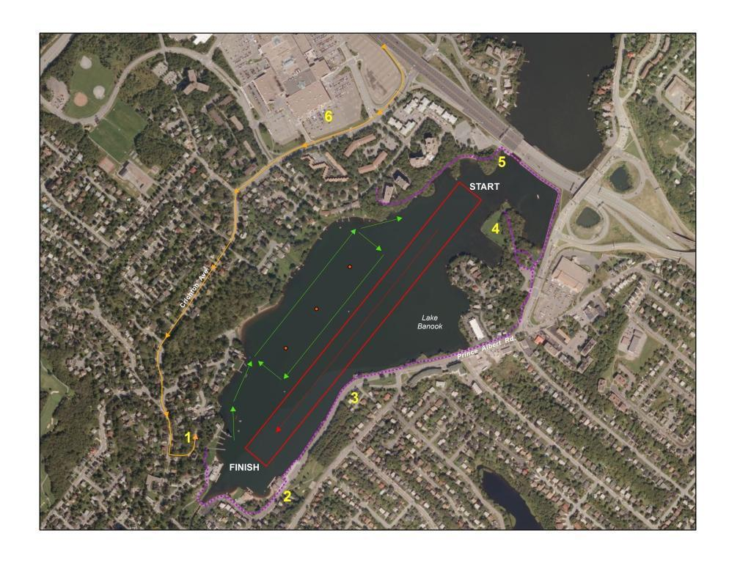

**Note: Friday PM Practice Flow Pattern:**

**Up Mic Mac side of the course and down the Lanes**

## Finish Area Map

|  |  |  |
| --- | --- | --- |
| 1. Judges Tower   * Medical * Control * Results * Official Launch   2. Launch Area   * Dock Marshall * General Information * Vendors   3. Trailer Parking  4. North Star Rowing  5. Oakwood House   * Safety Meeting * Medal Ceremony   6. General Parking  7. MicMac AAC |  | Trailer Parking From Trans Canada  Walking Trail  Outflow  Inflow |

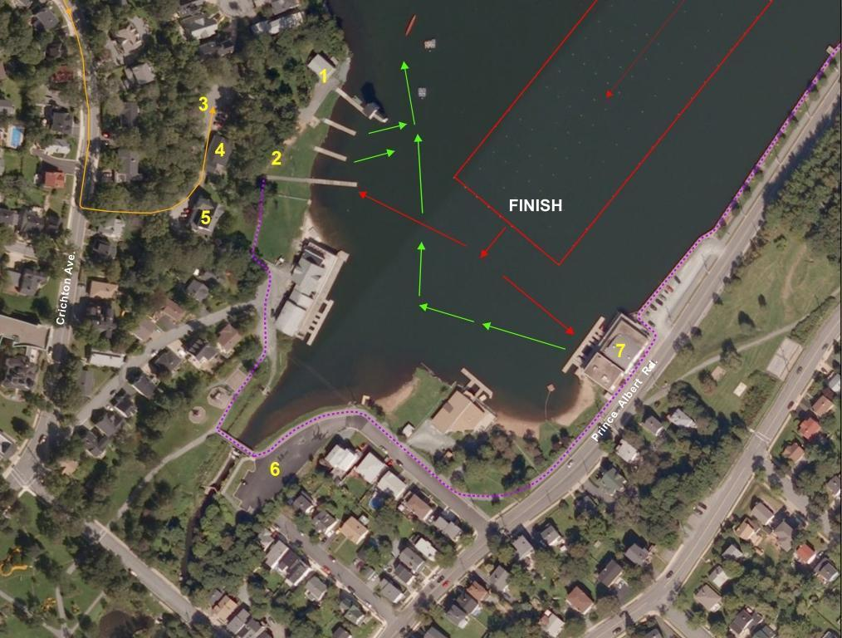

# DIRECTIONS

**From Trans Canada Highway, Provincial Route 118**

• Take Right **Exit** to *Eastern Shore/Eastern Passage* onto Highway 111

• Drive 0.5km and Exit 5 to MicMac Boulevard

• Follow MicMac Blvd changing to Glen Manor Dr. to stop sign at top of hill.

• Turn left onto Crichton Ave.

• Follow Crichton Ave approx. 850m to sign for Oakwood House and Banook Canoe Club. Turn Left onto this steep descent into the Trailer Parking Area.

**IF YOU GET LOST IN THE HALIFAX/DARTMOUTH AREA:**

Ask for directions to Banook Canoe Club. Banook Canoe Club is adjacent to North Star Rowing Club and Oakwood House.