**2024**

**COGSWELL/PELHAM**

**HALIFAX HARBOUR**

**CHAMPIONSHIP RACE**

**Sunday, September 29th, 2024**

***Hosted by:***



**2024 HALIFAX HARBOUR CHAMPIONSHIP RACE**

**RACE FORMAT**

**1) Halifax Harbour Championship Race (Cogswell Medal & Pelham Prize)**

Singles will race the 4 km Northwest Arm course in a time trial format (See Map Appendix I). Rowers will assemble according to bow numbers at the Point Pleasant Park end of the Northwest Arm at 8:00 am.

The starting order will be seeded from 2023 Sprint and Icebreaker results as well as coach input (new entrants will be added to the end of the start order, or at the Organizing Committee’s discretion). Each rower will be called through the start line in roughly 15-20 second intervals. Race results will be based on the time taken to complete the course.

**REGISTRATION**

1. Registration will be online through Regatta Central (www.regattacentral.com).

2. Registration will open Sept 16th and close Sept 25th at 10:00 PM Atlantic Time.

3. There will be a $15 late fee per entry for those who miss the registration window.

4. RCA numbers (or equivalent for out of country participants) MUST be included in order to complete the online registration.

5. The registration fee for the regatta is **$30 per participant plus $5 for RCA & RowNS seat fees.** Please note that all fees are due at the Safety Meeting on Sunday, September 29th.

6. Only exact cash, e-transfers ([payments@halifaxrowing.ca](mailto:payments@halifaxrowing.ca)) or cheques, made payable to ‘Halifax Rowing Club”, will be accepted.

**EVENTS SUMMARY**

|  |  |
| --- | --- |
|  | 1x |
| OPEN, Men and Women | X |

**FLIGHT SCHEDULE**

|  |
| --- |
| Cogswell & Pelham |
| 8:00 AM |

**CATEGORY RESTRICTIONS**

1. Open (O): Open to any age and gender.

**RULES OF RACING**

The Northwest Arm is a narrow waterway with many obstacles, including moored and mobile boats. The Organizing Committee, officials, and regatta participants have no way of restricting traffic along the Arm, so please be aware there may be wake and other obstacles associated with the movements of sailboats and motorboats. Please be aware of the traffic flow pattern, warm-up areas, and other vessels present along the Northwest Arm. This will ensure a safe and successful racing experience.

The Rowing Canada (RCA) Rules of Racing will apply for the duration of the Regatta.

**1. Starts**

The start of all races will be a running Head Race format.

**2. Passing**

In the event that a boat overtakes another boat, the Passer has the right of way to pass on the side of its choice, **IF** a safe pass can be accomplished.

**Please note:** If a pass is attempted and there is not adequate room and time to perform the pass, the Passer is at risk of incurring interference penalties subject to the Umpire’s decision. The boat being overtaken must yield and give suitable room to the Passer, if a safe pass can be accomplished. **All scullers:** be alert to possible upcoming passing attempts and promptly yield when there is adequate room and time.

**5. Penalties**

Penalties are as such: 30 seconds for a passing violation.

Note:

1. The Race Committee has the right to close the course and launch sites at any time during the regatta due to weather or safety concerns.
2. Scullers and crews: do not cut across the race course at any time during the regatta. Please follow the traffic flow pattern outlined in the race package.
3. Any boat showing a blatant disregard for safety will be penalized and may be disqualified from the regatta.

**MISCELLANY**

**1. Launching**

All visiting clubs must launch from the Halifax Rowing Club located at the St Mary’s Boat Club (SMBC), 1641 Fairfield Rd, Halifax

**2. Trailer Parking**

If using a trailer to transport shells, please contact the OC regarding expected arrival time of the trailer. The SMBC lot may not always be easily accessible due to functions in the hall.

**3. Security**

Security may be made available if trailer parking has been prearranged with HRC before Sept 16th.

**4. Safety Meeting**

There will be a Coaches’ Safety meeting the morning of the regatta, **Sunday, September 29th, 2024**, **at 6:30 AM at Halifax Rowing Club**. All coaches are required, and competitors are encouraged to attend. The major rules of the regatta and any safety concerns will be discussed at this time.

**5. Changes to the Draw**

All changes to the draw must be received by Friday, Sept 27 by 5:00 PM.

**6. Registration fees**

The Registration fee for the regatta is $30 per participant. This fee includes seat fees.

Registration fees must be paid in full at the safety meeting. Failure to do so will result in disqualification from the regatta.

**7. Awards**

Awards will take place at HRC following the race.

**CONTACT INFORMATION**

Brian Robinson

Regatta Chair

[hfx.rowing@gmail.com](mailto:hfx.rowing@gmail.com)

Halifax Rowing Club

[rowing@halifaxrowing.ca](mailto:rowing@halifaxrowing.ca)

[www.halifaxrowing.ca](http://www.halifaxrowing.ca)

Linda Lee

Chief Umpire

[linda_margaret_lee@hotmail.com](mailto:linda_margaret_lee@hotmail.com)

**HISTORY OF THE HALIFAX HARBOUR CHAMPIONSHIP AND THE COGSWELL MEDAL/PELHAM PRIZE**

The history of Canadian Rowing is rich with events, one of the most significant of which is the race for the Cogswell Belt in Halifax, Nova Scotia. Many of the chroniclers of Canadian history consider the institution of the Cogswell Race the beginning of competitive rowing in Canada.

Dr. Charles Cogswell, physician and founder of the event, was born in Halifax on May 12, 1813 and died in England on January 2, 1892. He was a distinguished Haligonian who contributed much to the city. As well as practicing medicine, Dr. Cogswell became a City Alderman and is credited with the production of the City Crest. In 1887, he proposed a design for the Canadian flag that was to contain a beaver, three maple leaves and a jewelled crown. In 1938, on his behalf, the Mayor presented to the Halifax Cricket Club a flag that embodied in visible shape for the first time the province’s Coat of Arms. In 1858, Dr. Cogswell donated four hundred dollars and a belt for annual competition by single scullers in Halifax Harbour. The winner of three consecutive championships would retain the belt. In 1880, Warren Smith won and retained the belt after which the winner received a silver medal. A silver clasp was awarded for each subsequent win, but the winner of three consecutive races would receive a medal of Nova Scotia gold. The traditional presentation by Row Nova Scotia of a silver medal and a cheque based on the interest of the fund to the winner of the Halifax Harbour Championship persists to this day.

In 1883, the original bequest was increased to one thousand dollars to be invested at not less than five percent and the interest used to pay for the medals. If, for any reason, the annual interest from the principal should be less than $50, the City of Halifax agreed to make up the difference. The Mayor of Halifax and the Chairman of Public Accounts were appointed the trustees of the fund, now called the Halifax Harbour Championship Fund.

The first competition was held in 1858. For the next decade, the Belt was won and held first by George Lovett and then George Brown. Other notable Haligonians to have won the race include John Mann, Stewart Cogswell, Joe Reardon, Daniel P. Wallace, Bill Martin, Bob Sawler (past President of the Nova Scotia Rowing Association), and Bud Myra. 1984 Olympic Bronze Medallist, Bob Mills, won in 1983, 1984, 1986, and 2001. PanAm medallist and Olympian Todd Hallett won the Championship in 1996 and in 2003. More recent winners include Lawrence Nwaesei (1997), Dafydd Davies (2000), Pat Cody (2002), and Chris Williams (2004). In 2007, Tony Landry (MicMac Rowing Club) captured the Cogswell medal for the third consecutive year (2005, 2006 and 2007) as well as Adam Bliss in 2013 (2011, 2012, 2013). Both were ceremoniously awarded the Cogswell Belt, which is on display at the Maritime Museum of the Atlantic.

The Pelham Prize was established as an award for the top finisher of the opposite sex from the Cogswell Medal in the Halifax Harbour Championship. The prize is named after local rowing champion Henry Pelham (1908-1978). Henry was an avid sportsman and a man of many talents. Henry rowed with both the Jubilee Rowing Club and the MicMac Rowing Club and won numerous races with various crews. Fiercely competitive, Henry rowed with the Jubilee 4- crew of 1930, which placed second in the British Empire Games (precursor to the Commonwealth Games). In 1932, Henry was named to the Canadian Olympic 4-.

– Adapted from the Charles Cogswell Harbour Rowing Championship Trust Nova Scotia Rowing Association, with contributions from Linda Lee.

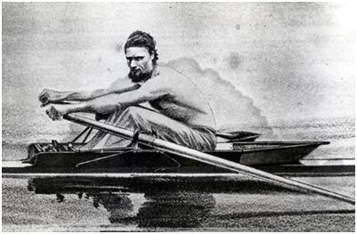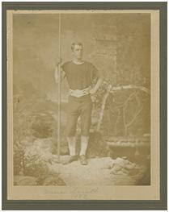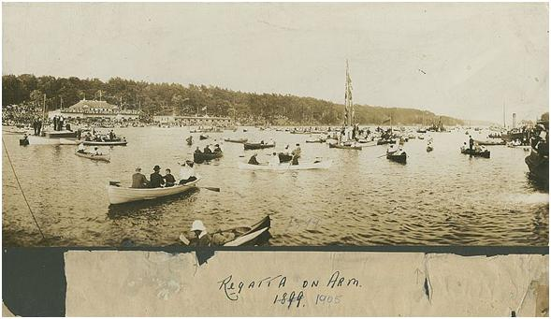

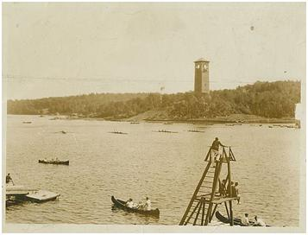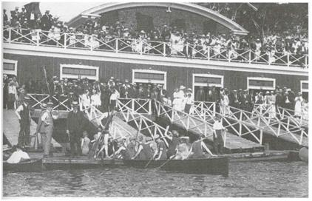

**Selection of historical rowing images on the Northwest Arm1**

Top: George Brown (Left) and Warren Smith (Right), both 5 time winners of the Halifax Harbour Championship in the 1860’s and 70’s.

Middle: Regatta’s on the Northwest Arm were often viewed by tens of thousands of spectators both on land and in pleasure boats.

Bottom: Rowing crews racing past the Dingle Tower in 1912 (left). The Northwest Arm Rowing Club (right) in 1919 was one of many rowing clubs on the Arm.

1 Images from the Nova Scotia Archives (Tom Connors: The Old Sport)

<http://gov.ns.ca/nsarm/virtual/connors/>

